Lab – Configuring Router for Subnets and NAT

Total points 100

Names of all team members: ___________Ashille Hodge, Takiyah Crawford__________________________________________

Please do not use any devices and cables on racks B and C because they are for another class. Only the tables by racks B and C can be used.

Description

In this lab, you will connect the Cisco 1900 Series Integrated Service Router to the lab network and configure it to communicate using the most common Cisco IOS (Cisco’s operating system) configuration commands. The router boot process is covered in this lab. You will also create a subnet in the lab’s private network to secure your laptop and communicate with the Internet. You will then create a new private network to hide your laptop’s IP address from other devices in the lab. The laptop will communicate with the Internet via the labs private network using NAT configured on the router. Set up the network according to the topology below.

Topology 1

Host02 (Laptop) Ethernet port connected to Router’s Gi0/0 interface. Host02 is also connected to the router management console. For racks B, C, D, E, F and G the router’s Gi0/1 interface is connected to the first Ethernet port labeled A in the patch panel above the switch. For rack A, the router’s Gi0/1 interface is connected to an Ethernet port of the Netgear switch on the rack.

The orange box placed on top of the lab cabinet contains Ethernet cables.

The lab network is on a 172.20.0.0 255.255.248.0 subnet of the college’s network of which IP addresses 172.20.0.11 to 172.20.0.79 are shared among the seven racks in the lab for VPN access. The subnet for each rack is assigned as follows.
For WAN interface of routers: 172.20.0.0 255.255.255.224
For rack A: 172.20.0.72 255.255.255.248
For rack D: 172.20.0.48 255.255.255.248
For rack E:172.20.0.40 255.255.255.248
For rack F: 172.20.0.56 255.255.255.248
For rack G: 172.20.0.64 255.255.255.248

IP addresses from the above subnets are used in the tables below. Use the table corresponding to your rack for assigning the IP addresses to devices. The steps to configure the IP addresses are given below the tables.

For rack A:
Device | Host Name | Interface | IP Address | Subnet Mask | Default  Gateway
Router | Ro-Lab | Gi0/0 | 172.20.0.73 | 255.255.255.248 | N/A
Router | Ro-Lab | Gi0/1 | 172.20.0.18 | 255.255.255.224 | N/A
Laptop | Host02 | NIC | 172.20.0.74 | 255.255.255.248 | 172.20.0.73

For rack B:
Device | Host Name | Interface | IP Address | Subnet Mask | Default  Gateway
Router | Ro-Lab | Gi0/0 | 172.20.0.81 | 255.255.255.248 | N/A
Router | Ro-Lab | Gi0/1 | 172.20.0.13 | 255.255.255.224 | N/A
Laptop | Host02 | NIC | 172.20.0.82 | 255.255.255.248 | 172.20.0.81

For rack C:
Device | Host Name | Interface | IP Address | Subnet Mask | Default  Gateway
Router | Ro-Lab | Gi0/0 | 172.20.0.89 | 255.255.255.248 | N/A
Router | Ro-Lab | Gi0/1 | 172.20.0.16 | 255.255.255.224 | N/A
Laptop | Host02 | NIC | 172.20.0.90 | 255.255.255.248 | 172.20.0.89

For rack D:
Device | Host Name | Interface | IP Address | Subnet Mask | Default  Gateway
Router | Ro-Lab | Gi0/0 | 172.20.0.49 | 255.255.255.248 | N/A
Router | Ro-Lab | Gi0/1 | 172.20.0.12 | 255.255.255.224 | N/A
Laptop | Host02 | NIC | 172.20.0.50 | 255.255.255.248 | 172.20.0.49

For rack E:
Device | Host Name | Interface | IP Address | Subnet Mask | Default  Gateway
Router | Ro-Lab | Gi0/0 | 172.20.0.41 | 255.255.255.248 | N/A
Router | Ro-Lab | Gi0/1 | 172.20.0.15 | 255.255.255.224 | N/A
Laptop | Host02 | NIC | 172.20.0.42 | 255.255.255.248 | 172.20.0.41

For rack F:
Device | Host Name | Interface | IP Address | Subnet Mask | Default  Gateway
Router | Ro-Lab | Gi0/0 | 172.20.0.57 | 255.255.255.248 | N/A
Router | Ro-Lab | Gi0/1 | 172.20.0.14 | 255.255.255.224 | N/A
Laptop | Host02 | NIC | 172.20.0.58 | 255.255.255.248 | 172.20.0.57

For rack G:
Device | Host Name | Interface | IP Address | Subnet Mask | Default  Gateway
Router | Ro-Lab | Gi0/0 | 172.20.0.65 | 255.255.255.248 | N/A
Router | Ro-Lab | Gi0/1 | 172.20.0.11 | 255.255.255.224 | N/A
Laptop | Host02 | NIC | 172.20.0.66 | 255.255.255.248 | 172.20.0.65

Step 1: Configure the host.

- In this lab we will configure a static IP address on the host (laptop). Connect the host as per the above topology. Configure the host to use the same IP subnet for the address and mask as on the router, as shown in the table above. Also, configure the IP address 8.8.8.8 for DNS on the host.

For Windows:
1. Make sure the laptop is connected properly to the router.
2. Go to Network and Sharing Center -> Change Adapter Settings
3. Right-click on the wired Ethernet connection and select properties
4. Double-click on TCP/IPv4
5. Select Use the following IP address:
6. Enter the settings.
7. Close all open windows including the Network and Sharing center
8. On the command prompt use ipconfig to check if the settings are correct
9. Go to Control Panel -> System and Security -> Windows Firewall -> Advanced Settings
10. Then Select Inbound Rules
11. Right-click and select enable rule for all entries listed as File and Printer Sharing (Echo Request – ICMPv4-In)
12. Then Select Outbound Rules
13. Right-click and select enable rule for all File and Printer Sharing (Echo Request – ICMPv4-Out)
14. The above rules are enabled to ensure that your computer can send or respond to ping requests and replies. Ping uses the Internet Control Message Protocol version 4 (ICMPv4) instead of TCP or UDP. ICMPv4 is known as a maintenance protocol and considered part of the Internet layer. ICMP packets are encapsulated within IP datagrams. ICMP is used to build and maintain routing tables, diagnose network related issues and perform router discovery.
15. Close all open windows

For Mac:
Use System Preferences -> Network. Configure the IP address, subnet mask, default gateway (Router) and DNS server.

Step 2: Console into the router.

Complete the steps in the attached document to configure access to the router. Cable the console connection (USB port on laptop to console port on the router) using USB-DB9 connector to DB9-RJ45 connector. Use putty on Windows or terminal on Mac or Linux. Press Enter. You may see a prompt to enter the initial configuration dialog. Respond by entering no at the prompt and press Enter.

Would you like to enter the initial configuration dialog? [yes/no]: no
Router>
If the prompt to enter the initial configuration dialog does not appear, the prompt Router> or LabX> or something similar will appear.

In the steps below, you will reload and reset the router, and then examine the router settings, such as current router configuration and interface properties.

You can access all the router IOS commands in privileged EXEC mode. IOS commands are classified under Base modes, and Configuration Modes and Submodes. Access to privileged EXEC mode should be restricted by password protection to prevent unauthorized use because it provides direct access to global configuration mode and commands used to configure operating parameters.

The privileged EXEC mode command set includes those commands contained in user EXEC mode, as well as the configure command through which access to the remaining command modes is gained. Use the enable command to enter privileged EXEC mode as shown below.

Step 3: Erasing and reloading the router.

a. Enter privileged EXEC mode by typing enable.

Router>enable

Press enter and you should see the prompt (Router#), then continue to step 3.b. If asked for a password, try the following passwords Lab-IPv6, Lab-DHCPv6, Itec_Lab_1209, Lab_ro_1209, Itec-Lab-Ro, ItecLabRo, Lab, Itec-Lab, Lab-Ro, Lab_ro, ItecLab-Temp. If they do not work ask the instructor.

b. In privileged EXEC mode, enter the erase startup-config command.

Router#erase startup-config

The responding line prompt is:

Erasing the nvram filesystem will remove all files! Continue? [confirm]

c. Press Enter to confirm.

The response is:

Erase of nvram: complete

d. In privileged EXEC mode, enter the reload command.

Router#reload

The responding line prompt is:

System configuration has been modified. Save? [yes/no]:

e. Type n and then press Enter.

The responding line prompt is:

Proceed with reload? [confirm]

f. Press Enter to confirm.

The first line of the response is:

Reload requested by console.

After the router has reloaded, the line prompt is:

Would you like to enter the initial configuration dialog? [yes/no]:

g. Type n and then press Enter.

The responding line prompt is:

Press RETURN to get started!
h. Press Enter.

The router is ready for the assigned lab to be performed.

Step 4: Configure the router.

Perform each of the following steps for the router:

- Configure a host name for the router. You will be at the user EXEC mode prompt on the router with a prompt of Router>.
Use the enable command to enter privileged EXEC mode.

Router>enable
Router#
Notice that the prompt changed in the configuration to reflect privileged EXEC mode.

Enter global configuration mode. This mode allows the execution of commands that can configure various settings such as hostname, IP address, subnet mask and default route.

Router#configure terminal Router(config)#hostname Ro-Lab

- Configure the router to not attempt to resolve host names using a DNS server. If this is not
configured, the router assumes that any mistyped command is a host name and attempts to resolve it by looking for a DNS server. On some routers, it can take considerable time before the prompt returns.

Ro-Lab(config)#no ip domain lookup

- Configure the router so that console messages do not interfere with command input. This is helpful when exiting configuration mode, because it returns you to the command prompt and prevents having messages from breaking into the command line.

Ro-Lab(config)#line console 0
Ro-Lab(config-line)#logging synchronous
Ro-Lab(config-line)#exit
Ro-Lab (config)#exit
Ro-Lab#

- From the privileged EXEC prompt, issue the show running-config command. This command can be abbreviated as sh run. Verify the configured settings on the router.

Ro-Lab#show running-config
- Configure the router interfaces: (Some of the commands have short cuts. For example, the shortcut for configure terminal is conf t). When configuring an interface, always use the no shutdown command to enable it. The no shutdown command turns on the interface. The shutdown command turns the interface off. Use the IP address and subnet mask from the table above in the ip address command.
Ro-Lab#conf t
Ro-Lab(config)#interface Gi0/0
Ro-Lab(config-if)#description LAN link
Ro-Lab(config-if)#no shutdown
Ro-Lab(config-if)#ip address IPADDR_FROM_TABLE_ABOVE SUBNETMASK_FROM_TABLE_ABOVE
Ro-Lab(config-if)#

Note: The no shutdown command turns on the interface. The shutdown command turns the interface off.

Ro-Lab(config-if)#end
Ro-Lab#

Enter the show interfaces command. Verify that the Gi0/0 IP address is correctly configured.

Ro-Lab#show interfaces Gi0/0

Ro-Lab#conf t
Enter configuration commands, one per line. End with CNTL/Z.
Ro-Lab(config)#int Gi0/1
Ro-Lab(config-if)#description WAN link
Ro-Lab(config-if)#no shut
Ro-Lab(config-if)#ip address IPADDR_FROM_TABLE_ABOVE SUBNETMASK_FROM_TABLE_ABOVE

Configure the default route. The default route that points to the gateway IP address 172.20.0.1 is configured with the following command:
Ro-Lab(config-if)#ip route 0.0.0.0 0.0.0.0 172.20.0.1

Ro-Lab(config-if)#end
Ro-Lab#

Enter the show interfaces command. Verify that the Gi0/1 IP address is correctly configured.

Ro-Lab#show interfaces Gi0/1

Display running configuration to check if the configuration parameters have been set correctly.
Ro-Lab#sh run

Display the routing table entries. Verify the IP addresses, subnet masks and default route.
Ro-Lab#sh ip route

Test connectivity by pinging to an IP address on the Internet:
Ro-Lab#ping 8.8.8.8

From the router (through putty) and host (through command prompt) ping all other IP addresses in the table.
To test connectivity to the Internet, from the host (through command prompt) ping www.google.com
Provide a screenshot for the host pinging www.google.com:
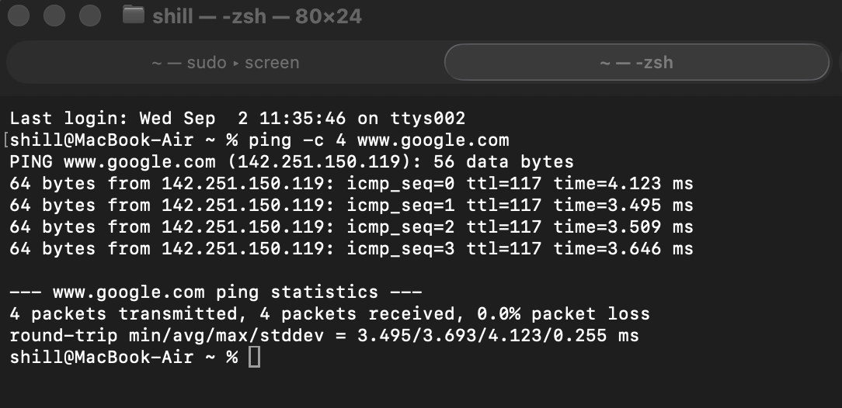

On the host open a Web browser and connect to www.google.com. Test connectivity to other Websites.

Save the running configuration to the startup configuration from the privileged EXEC prompt.

Ro-Lab#copy running-config startup-config

Note: The running configuration is saved for the next time that the router is restarted. The router can be restarted either by a software reload command or a power cycle. The running configuration is lost if it is not saved. The router uses the startup configuration when the router is started.

Copy the router configuration to a text file as explained below:
Type “show startup-config” to display the saved configuration. Click and hold at the beginning of the output from the “show startup-config” command, then drag down to the bottom of the PuTTY window. This should select all the text on the screen. Copy the text using CTRL-C. Paste the text into notepad. Name the file startup-config1.txt.

Topology 2

The cable connections remain unchanged.

Device | Host Name | Interface | IP Address | Subnet Mask | Default  Gateway
Router | Ro-Lab | Gi0/0 | 192.168.0.1 | 255.255.255.0 | N/A
Router | Ro-Lab | Gi0/1 | 172.20.0.x* | 255.255.254.0 | N/A
Laptop | Host02 | NIC | 192.168.0.3 | 255.255.255.0 | 192.168.0.1

*: x should be the same number you used for topology 1.

Step 1: Configure the host and router.

- In this part we will configure static IP address on the host and NAT on the router. NAT is used for public/private IP address translation. NAT secures the private IP address of the host because it replaces the private IP address with a public IP address for Internet access. The private IP address does not leave the network. Only the public IP address is transmitted on the Internet. But, because the lab has access to the public Internet only through the college network, we will translate between class B/class C private IP addresses. Configure the host to use the same IP subnet for the address and mask as on the router, as shown in the table above. Also, configure the IP address 8.8.8.8 for DNS on the host.

- Configure the router interfaces:
Ro-Lab#conf t
Ro-Lab(config)#int Gi0/0
Ro-Lab(config-if)#no ip address
Ro-Lab(config-if)#ip address 192.168.0.1 255.255.255.0
Ro-Lab(config-if)#no shut

Configure NAT for the LAN interface
Ro-Lab(config-if)#ip nat inside
Ro-Lab(config-if)#
*Feb 13 18:26:03.630: %LINEPROTO-5-UPDOWN: Line protocol on Interface NVI0, changed state to up

Ro-Lab(config-if)#end
Ro-Lab#
*Feb 13 18:28:56.518: %SYS-5-CONFIG_I: Configured from console by console
Ro-Lab#conf t
Enter configuration commands, one per line.

Ro-Lab(config)#int Gi0/1
Ro-Lab(config-if)#no ip address
Ro-Lab(config-if)#ip address 172.20.0.x 255.255.254.0
Ro-Lab(config-if)#no shut

Configure NAT for the WAN interface
Ro-Lab(config-if)#ip nat outside

Next you will configure an access list to specify which private IP address are allowed to NAT on the LAN interface. Only devices in the LAN with these IP addresses will be permitted to communicate with the Internet. For example, to permit IP address 192.168.25.15 to NAT on the LAN interface, the following two commands are used:
ip nat inside source list 1 interface Gi0/1 overload
access-list 1 permit 192.168.25.15 0.0.0.0
“permit 192.168.25.15 0.0.0.0” is the Access list rule.
Another example is, in the access list on a Cisco router: access-list 1 permit 172.18.0.0 0.0.255.255, the rule permit 172.18.0.0 0.0.255.255 allows all IP addresses in the range 172.18.0.1 - 172.18.255.254.
Additional examples:
The rule deny 0.0.0.0 255.255.0.0 will disallow all IP addresses 0.0.0.0 to 255.255.0.0.
The rule deny 10.254.0.0 0.0.255.0 will disallow all IP addresses 10.254.0.0 10.254.255.0.

The following commands permit IP addresses 192.168.0.1 - 192.168.0.254 to NAT on the LAN interface. The appropriate access list rule is provided in the second command.
Ro-Lab(config)#ip nat inside source list 1 interface Gi0/1 overload
Ro-Lab(config)#access-list 1 permit 192.168.0.0 0.0.0.255
Ro-Lab(config)#end
Ro-Lab#
*Feb 13 18:35:54.794: %SYS-5-CONFIG_I: Configured from console by console

Display running configuration
Ro-Lab#sh run

Display the routing table entries. Verify the IP addresses and subnet masks.
Ro-Lab#sh ip route

Test connectivity by pinging to an IP address on the Internet:
Ro-Lab#ping 8.8.8.8

Save the router’s running configuration.
Ro-Lab#copy run start

From the router and host ping all other IP addresses in the table for topology 2.
To test connectivity to the Internet, from the host ping www.google.com.
Provide a screenshot for the host pinging www.google.com:
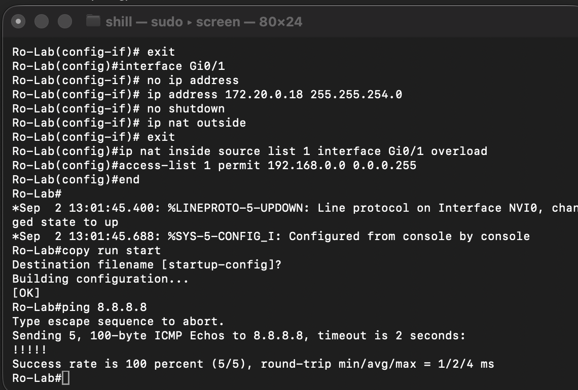

Copy the router configuration to a text file as explained below:
Type “show startup-config” to display the saved configuration. Click and hold at the beginning of the output from the “show startup-config” command, then drag down to the bottom of the PuTTY window. This should select all the text on the screen. Copy the text using CTRL-C. Paste the text into notepad. Name the file startup-config2.txt.
Step 2: Network Latency and PDU Sizes

Download Wireshark Protocol Analyzer from https://www.wireshark.org/download.html and install it on your laptop.
On Windows:
- Make sure to install Npcap when you are prompted.
- Make sure to install USBPcap when you are prompted.
On Mac you will also need to install Wireshark to the applications folder and also install ChmodBPF and system path packages.
The latency of the network is the time interval (or delay) between the time a transmitting host sends a packet onto the network and the time the transmitting host begins to receive a packet in reply from the receiving host. The latency of a network is measured in milliseconds. The latency is directly proportional to the distance between any two communicating hosts. The speed of the network is inversely proportional to its latency. The bandwidth of the network is related to its speed and is measured in bits per second.
The echo request and echo reply ICMP messages are encapsulated In an IP datagram, which in turn is encapsulated in an Ethernet frame. These PDUs are collectively also called a frame. The ping command gives the average round trip time (RTT) of the frames it sends. The RTT is the time span between a host sending the frame containing the echo request and receiving the frame containing the echo reply. The average RTT is used to estimate the latency of the network. The smaller the frame size (length in bytes), the greater is the accuracy in measuring the latency.
- By default, ping sends ICMP messages of 32 bytes each on Windows (different for Mac/Linux). Verify this by pinging www.google.com. Now, let’s find the smallest possible frame size for each of these messages. At the command prompt, type ping -n 10 -l 0 www.google.com and press Enter. 18. On Mac/Linux, use ping –c 10 –s 0 www.google.com. The commands will send 10 frames of 0 bytes data. Even though the size of the ICMP message data is zero, the frame size is not zero because each protocol adds its own header information that includes addresses and other fields.

- To find the total number of bytes of the smallest possible frame size we will use Wireshark. Start Wireshark. Then start the network packet capture by double clicking on the active Ethernet interface. Enter icmp in the textbox of the display filter and press Enter. Run the above ping command and capture the packets.

- Stop the packet capture. Save the capture file as ping_capture1.
Paste a screenshot of the captured information from Wireshark without opening any PDUs: 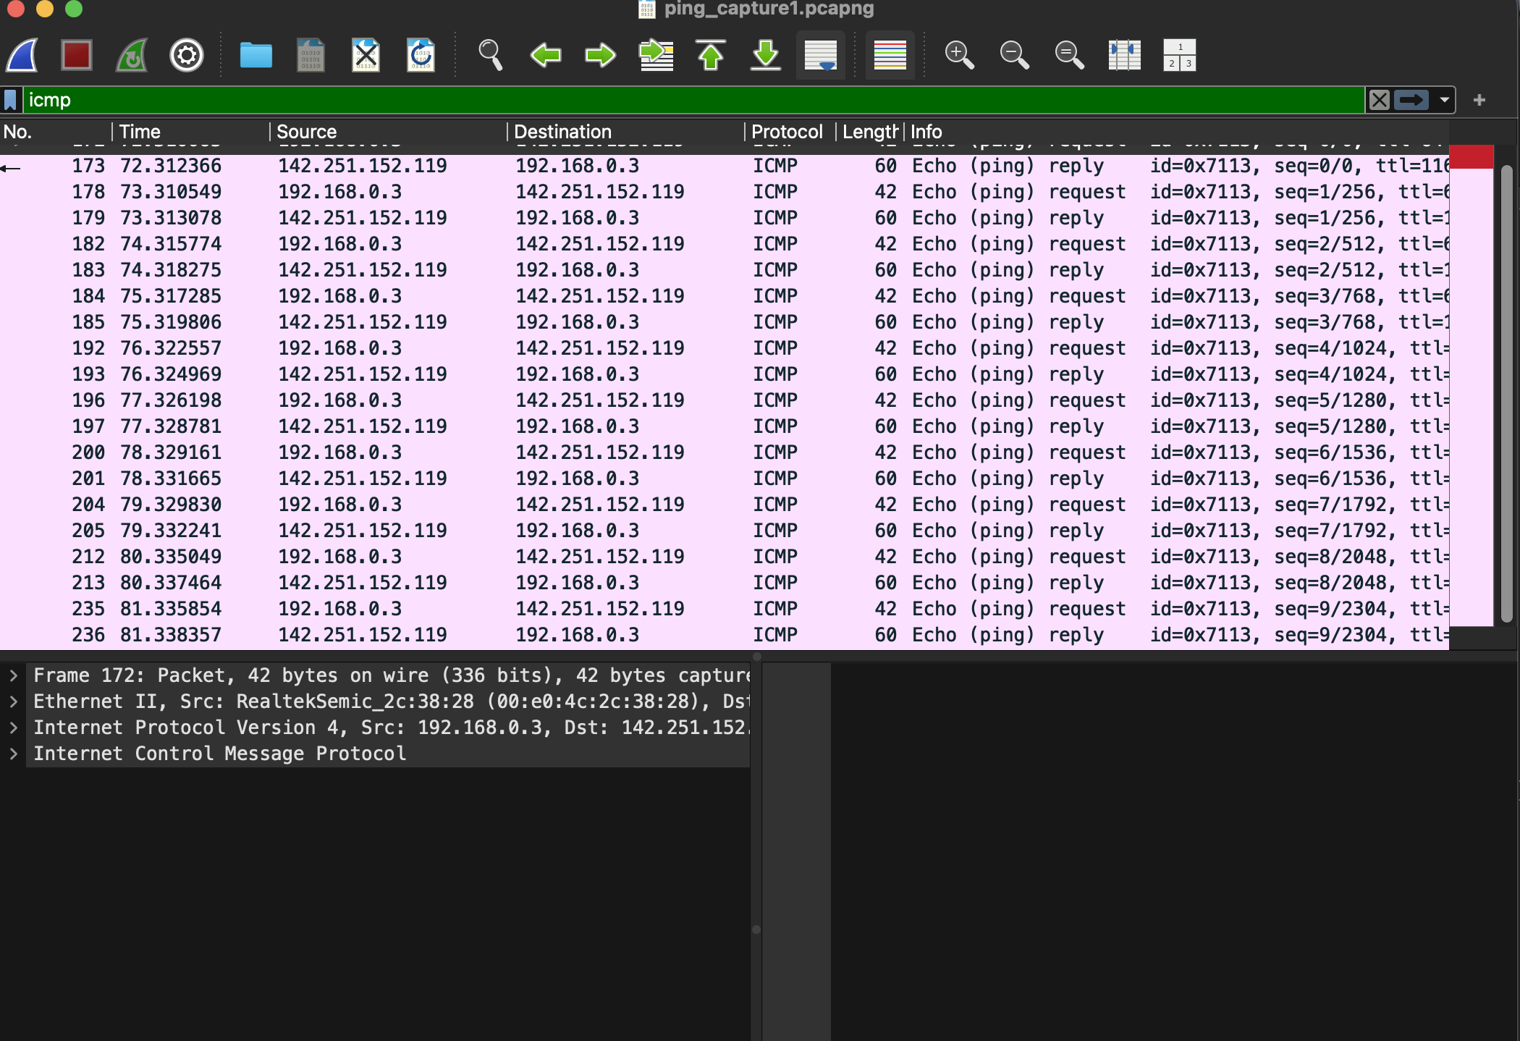

- Double click on an echo (ping) request. The frame size (Frame length) can be found by expanding Frame. This is the smallest frame that can be transmitted on the network.
  - What is the frame size in bytes?
Answer: 60 bytes

- The smallest frame is composed of the Ethernet, IP and ICMP headers. The ICMP data size is zero bytes. Next, you will find the Ethernet, IP and ICMP header sizes. Clicking on Ethernet II highlights (in the box below) the hexadecimal digits used for the Ethernet header. A hexadecimal digit represents four bits.
  - What is the Ethernet header size in bytes?
Answer: 14 bytes

- Clicking on Internet Protocol Version 4 highlights the hexadecimal digits used for the IP header.
  - What is the IP header size in bytes?
Answer: 20 bytes

- Clicking on Internet Control Message Protocol highlights the hexadecimal digits used for the ICMP header.
  - What is the ICMP header size in bytes?
Answer: 8 bytes

- The total of the Ethernet, IP and ICMP header sizes should be equal to the smallest frame size. For the latency, note the average RTT time for the smallest frame from the ping on the command prompt or terminal. On Mac/Linux, the average RTT can only be observed for an ICMP data size of 16 or more bytes. On Mac/Linux, use ping –c 10 –s 16 www.google.com.
  - What is the latency?
Answer: 2.661/2.816/2.937/0097 ms

- Now let’s send the largest frame size. The largest frame size cannot exceed the largest Ethernet frame size of 1514 bytes. To send the largest frame size we will require 1514 - total of the Ethernet, IP and ICMP header sizes = 1472 bytes of data. Any larger data size will result in the IP datagram becoming larger than the Ethernet data field. This will cause the IP datagram to be divided and sent in two or more Ethernet frames. This process is known as fragmentation and you will observe it in the next step. Start a new Wireshark capture. On the command prompt, type ping –l 1472 www.google.com and press Enter. This command will send frames of 1472 bytes data. Stop the packet capture. Save the capture file as ping_capture2.
Paste a screenshot of the information from Wireshark showing the frame size: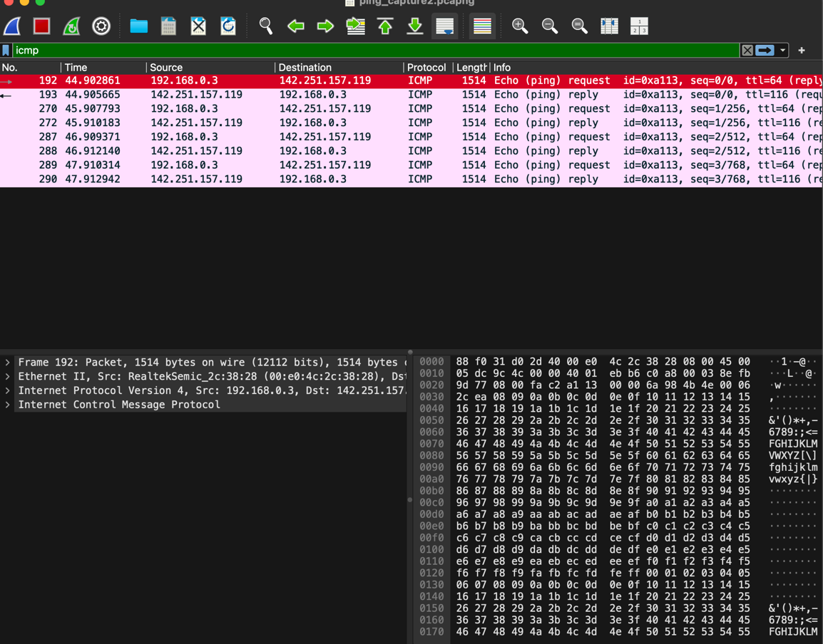

- Start a new Wireshark capture. At the command prompt, type ping –l 1473 www.google.com and press Enter. This command will send frames of 1473 bytes data. Stop the packet capture. Save the capture file as ping_capture3. Since the largest frame size would be exceeded by one byte, the data in each IP datagram is fragmented and sent in two frames. Use Wireshark to find the sizes of the two IP fragments. The fragment sizes can be found by expanding Internet Protocol Version 4 datagram and then expanding IPv4 Fragments.
  - What are the fragment sizes in bytes?
Answer:
Paste a screenshot of the relevant information in Wireshark: 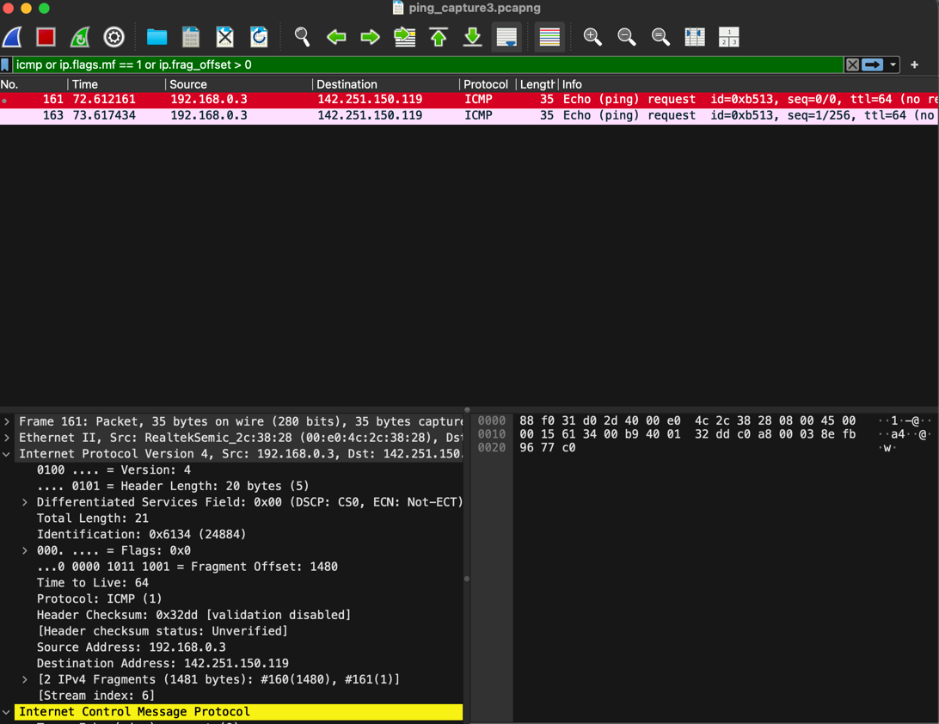

- Start a new Wireshark capture. At the command prompt, type ping –l 3600 www.google.com and press Enter. Stop the packet capture. Save the capture file as ping_capture4. Use Wireshark to find the sizes of the IP fragments and the reassembled IPv4 length. The reassembled IPv4 length can be found by expanding Internet Protocol Version 4 packet and then expanding IPv4 Fragments.
  - What are the fragment sizes in bytes? What is the reassembled IPv4 length in bytes?
Answer:
Paste a screenshot of the relevant information in Wireshark: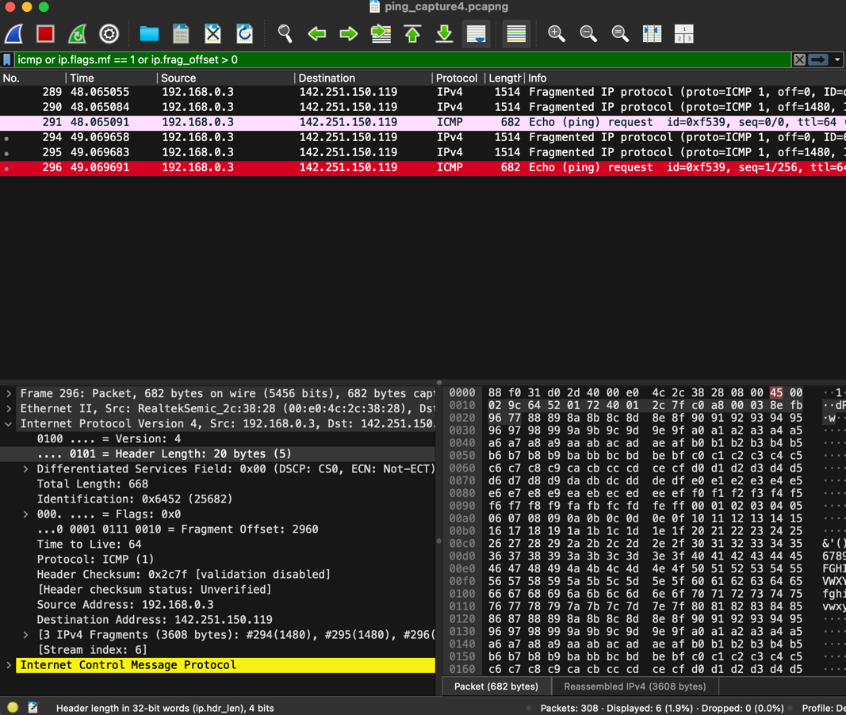

Step 3: ARP

We will now capture and observe Address Resolution Protocol (ARP) frames. ARP is used to resolve a IP address to a MAC address. It is what a computer uses to find the MAC address of the default gateway. Start a new Wireshark packet capture. Enter arp into the filter textbox.

- In order to observe your computer sending and receiving ARP messages to obtain MAC addresses, we’ll need to clear the ARP cache, since otherwise your computer is likely to find a needed IP-MAC address translation pair in its cache and consequently not need to send out an ARP message. On Windows the arp –d * command will clear your ARP cache. The –d flag indicates a deletion operation, and the * is the wildcard that says to delete all table entries. In order to run this command, you’ll need administrative/root privileges. On Windows, search for cmd and right-click on it and select Run as administrator. Then on the command prompt enter the command arp –d *. On MacOS/Linux enter sudo arp –d –a or arp –d IP_Addr_Gateway.

- If no packets are captured, open a command prompt or terminal and ping the default gateway or www.google.com. Another option is to open a Web browser and browse to www.google.com.

- Stop Wireshark packet capture when the ARP request and reply messages appear. The info of the request message will contain: Who has Default_Gateway_IP_Address? Tell Capturing_Interface_IP Address. The default gateway’s IP address and capturing interface’s IP address can be found with the ipconfig command. The info of the response message will contain: Default_Gateway_IP_Address is at MAC_Address. There may be multiple such packets captured. Use any one pair.

- Save the packet capture on the Desktop with the filename ARP_capture.

- Expand the ARP request message and provide a screenshot. The request is broadcast to find the MAC address of the target device.
Screenshot:
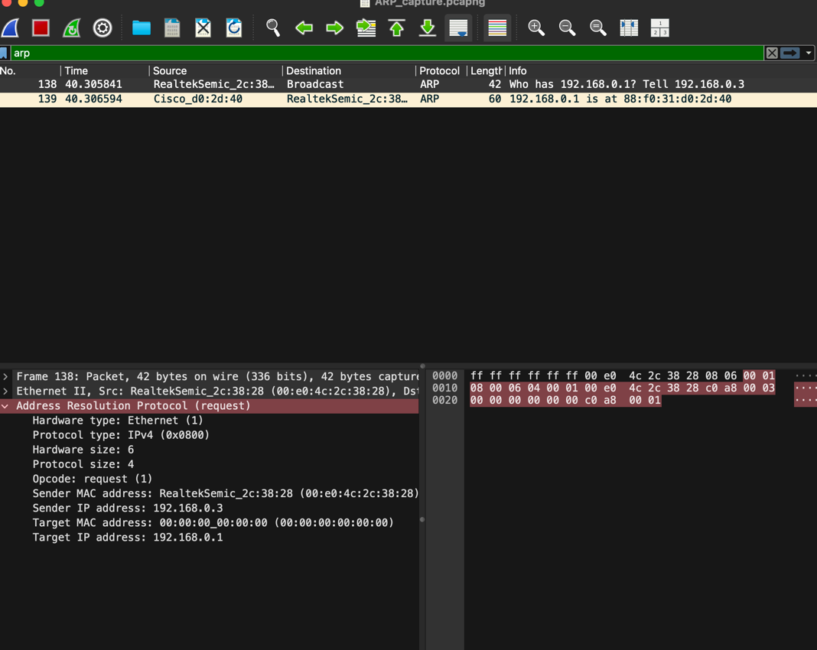

- Expand the ARP response message and provide a screenshot. Only the target device will reply to the ARP request.
Screenshot:
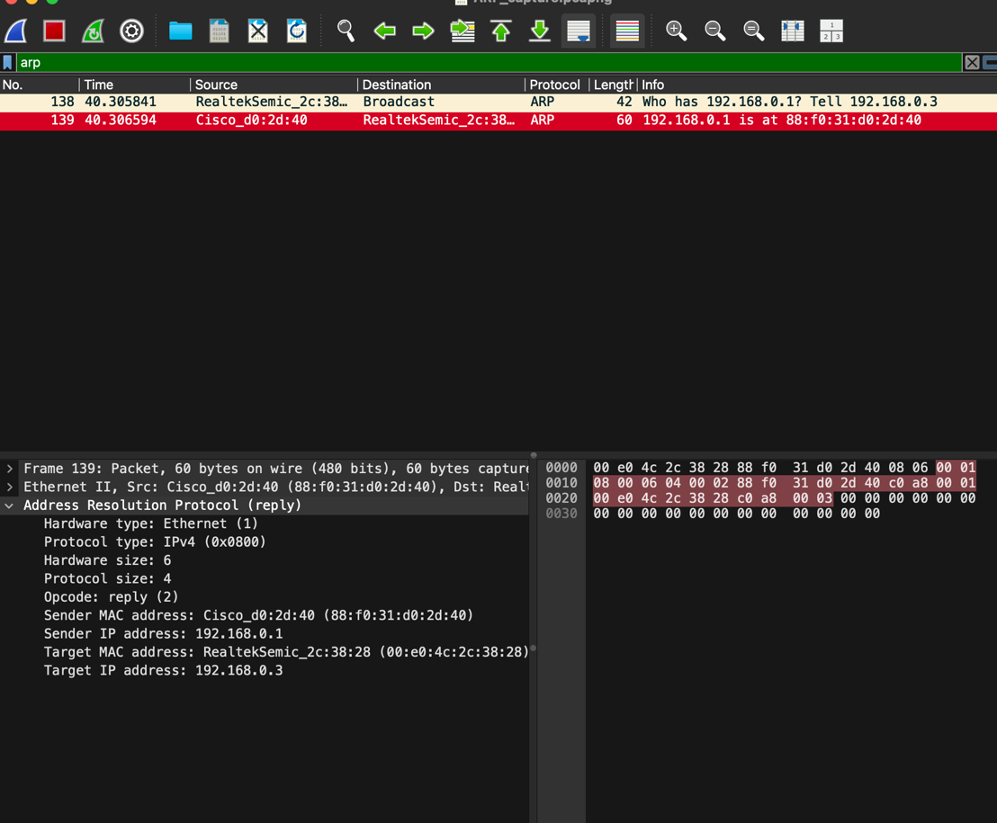

- What are the source and destination address in the Ethernet frame containing the ARP request message?
Answer: Source Address: 00:E0:4C:2C:38:28 Destinationa Address: ff:ff:ff:ff:ff:ff

- Give the value for the Ethernet Frame type field.
Answer: 0x0806
- What is the value of the opcode field within the ARP-payload part of the Ethernet frame in which an ARP request is made? How many bits is the opcode field?
Answer: Opcode value: 1 Size: 16 bits

- What is the IP address of the sender and target in the ARP message?
Answer: Sender IP: 192.168.0.3 Target IP: 192.168.0.1

- Now for the ARP reply that was sent in response to the ARP request, what is the value of the opcode field within the ARP-payload part of the Ethernet frame in which the ARP response is made?
Answer: 2 Reply

- What is the IP address of the sender and target in the ARP message?
Answer: Answer: Sender IP: 192.168.0.3 Target IP: 192.168.0.1

- What are the source and destination address in the Ethernet frame containing the ARP reply message? What is the “answer” to the ARP request?
Answer: Source address: 88:f0:31:d0:2d:40 Destination Address: 00:e0:4c:2c:38:28 “Answer” :88:f0:31:d0:2d:40
Step 4: Router memory and boot process.
In this section, you will study the main memory components of a Cisco router and how the boot process takes place. Read and follow the steps below.
Types of memory:
Generally Cisco routers (and switches) contain four types of memory:
ROM: Stores the router’s bootstrap startup program called ROM Monitor (or ROMmon), operating system software, and power-on diagnostic test programs (POST). When a router is powered on, the bootstrap runs a hardware diagnostic called POST (Power-On Self-Test).
Flash Memory: Generally referred to simply as “flash”, the IOS images are held here. Flash is erasable and reprogrammable ROM. Flash memory content is retained by the router on reload.
RAM: Stores operational information such as routing tables and the running configuration file. RAM contents are lost when the router is powered down or reloaded.
Non-volatile RAM (NVRAM): Holds the router’s startup configuration file. NVRAM contents are not lost when the router is powered down or reloaded.
Router boot process:
The following details the router boot process:
1. The router is powered on (or reload command is entered).
2. Enter the reload command. The router first runs Power-On Self-Test (POST).
Output will be similar to:
System Bootstrap, Version 15.0(1r)M1, RELEASE SOFTWARE (fc1)
Copyright (c) 2009 by cisco Systems, Inc.
TAC:Home:SW:IOS:Specials for info
C2900 platform with 524288 Kbytes of main memory
3. The bootstrap checks the Configuration Register value to specify where to load the IOS. By default (the default value of Configuration Register is 2102, in hexadecimal), the router first looks for “boot system” commands in startup-config file. If it finds these commands, it will run boot system commands in order they appear in startup-config to locate the IOS. If not, the IOS image is loaded from Flash. If the IOS is not found in Flash, the bootstrap can try to load the IOS from TFTP server or from ROM (mini-IOS).
Output will be similar to:
Self decompressing the image : ###############################
##############################################################
##############################################################
##############################################################
############################### [OK]
Restricted Rights Legend
4. After the IOS is found, it is loaded into RAM.
Output will be similar to:
Use, duplication, or disclosure by the Government is
subject to restrictions as set forth in subparagraph
(c) of the Commercial Computer Software - Restricted
Rights clause at FAR sec. 52.227-19 and subparagraph
(c) (1) (ii) of the Rights in Technical Data and Computer
Software clause at DFARS sec. 252.227-7013.

cisco Systems, Inc.
170 West Tasman Drive
San Jose, California 95134-1706

Cisco IOS Software, C2900 Software (C2900-UNIVERSALK9-M), Version 15.0(1)M1,
RELEASE SOFTWARE (fc1)
Technical Support: http://www.cisco.com/techsupport
Copyright (c) 1986-2009 by Cisco Systems, Inc.
Compiled Wed 02-Dec-09 15:23 by prod_rel_team

Cisco CISCO2921/K9 (revision 1.0) with 475136K/49152K bytes of memory.
Processor board ID FHH1230P04Y
1 DSL controller
3 Gigabit Ethernet interfaces
9 terminal lines
1 Virtual Private Network (VPN) Module
1 Cable Modem interface
1 cisco Integrated Service Engine-2(s)
Cisco Foundation 2.2.1 in slot 1
DRAM configuration is 64 bits wide with parity enabled.
255K bytes of non-volatile configuration memory.
248472K bytes of ATA System CompactFlash 0 (Read/Write)
62720K bytes of ATA CompactFlash 1 (Read/Write)
5. The IOS attempts to load the configuration file (startup-config) from NVRAM to RAM. If the startup-config is not found in NVRAM, the IOS attempts to load a configuration file from TFTP. If no TFTP server responds, the router enters Setup Mode (Initial Configuration Mode).
Output will be similar to:
--- System Configuration Dialog ---

Would you like to enter the initial configuration dialog? [yes/no]:
In short, when powered on the router needs to do:
1. Run POST to check hardware.
2. Search for a valid IOS (the Operating System of the router).
3. Search for a configuration file (all the configurations applied to this router).
Complete the rest of the reload process by entering n at the system configuration dialog.
Provide a screenshot showing the completion of the reload process:
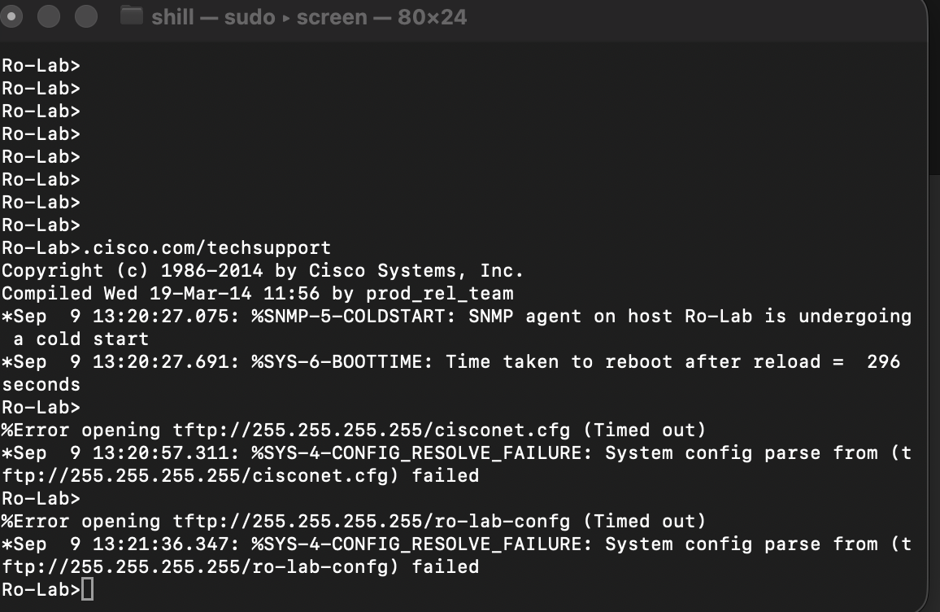

Type your name in the space provided at the beginning of this document. Upload this document containing nine screenshots to the Dropbox on D2L. Upload the five Wireshark capture files. Also upload the text files startup-config1.txt and startup-config2.txt. All students must Zip and upload their document and text files. There are 5 points for zipping and 5 points for placing the screenshots in the appropriate places in this document.

Important note: The steps below are to be done only if none of the given passwords above worked. Do not do the steps below if you were able to get into the router and configure it as described above. If you need to do the steps below, please ask the instructor before beginning.
Password recovery procedure.
You should know how to recover passwords configured on the router in case of unknown or forgotten passwords. This section provides an example of the password recovery procedure. Console into the router.

Router>enable
Password:
Password:
Password:
% Bad secrets

Type show version at the prompt, and record the configuration register setting. The configuration register is typically set to 0x2102.

Router>show version

Cisco IOS Software, C2900 Software (C2900-UNIVERSALK9-M), Version 15.0(1)M1,
RELEASE SOFTWARE (fc1)
Technical Support: http://www.cisco.com/techsupport
Copyright (c) 1986-2009 by Cisco Systems, Inc.
Compiled Wed 02-Dec-09 15:23 by prod_rel_team

ROM: System Bootstrap, Version 15.0(1r)M1, RELEASE SOFTWARE (fc1)

c2921-CCP-1-xfr uptime is 2 weeks, 22 hours, 15 minutes
System returned to ROM by reload at 06:06:52 PCTime Mon Apr 2 1900
System restarted at 06:08:03 PCTime Mon Apr 2 1900
System image file is "flash:c2900-universalk9-mz.SPA.150-1.M1.bin"
Last reload reason: Reload Command

This product contains cryptographic features and is subject to United
States and local country laws governing import, export, transfer and
use. Delivery of Cisco cryptographic products does not imply
third-party authority to import, export, distribute or use encryption.
Importers, exporters, distributors and users are responsible for
compliance with U.S. and local country laws. By using this product you
agree to comply with applicable laws and regulations. If you are unable
to comply with U.S. and local laws, return this product immediately.

A summary of U.S. laws governing Cisco cryptographic products may be found at:
http://www.cisco.com/wwl/export/crypto/tool/stqrg.html

If you require further assistance please contact us by sending email to
export@cisco.com.

Cisco CISCO2921/K9 (revision 1.0) with 475136K/49152K bytes of memory.
Processor board ID FHH1230P04Y
1 DSL controller
3 Gigabit Ethernet interfaces
9 terminal lines
1 Virtual Private Network (VPN) Module
1 Cable Modem interface
1 cisco Integrated Service Engine-2(s)
Cisco Foundation 2.2.1 in slot 1
DRAM configuration is 64 bits wide with parity enabled.
255K bytes of non-volatile configuration memory.
248472K bytes of ATA System CompactFlash 0 (Read/Write)
62720K bytes of ATA CompactFlash 1 (Read/Write)
Technology Package License Information for Module:'c2900'

----------------------------------------------------------------
Technology Technology-package Technology-package
Current Type Next reboot
-----------------------------------------------------------------
ipbase ipbasek9 Permanent ipbasek9
security securityk9 Permanent securityk9
uc uck9 Permanent uck9
data datak9 Permanent datak9

Configuration register is 0x2102
Router>

Use the power switch in order to turn off the router, and then turn the router back on. Send a Break by right-clicking on the top border of the Putty terminal after you see the message program load complete, entry point: 0x80008000, size: 0x6fdb4c in order to put the router into ROMMON. The value of the entry point may be different from this example.

rommon 1 > confreg 0x2142

rommon 2 > reset

System Bootstrap, Version 15.0(1r)M1, RELEASE SOFTWARE (fc1)
Copyright (c) 2009 by cisco Systems, Inc.
TAC:Home:SW:IOS:Specials for info
C2900 platform with 524288 Kbytes of main memory

program load complete, entry point: 0x80008000, size: 0x6fdb4c

Self decompressing the image : ###############################
##############################################################
##############################################################
##############################################################
############################### [OK]

Restricted Rights Legend

Use, duplication, or disclosure by the Government is
subject to restrictions as set forth in subparagraph
(c) of the Commercial Computer Software - Restricted
Rights clause at FAR sec. 52.227-19 and subparagraph
(c) (1) (ii) of the Rights in Technical Data and Computer
Software clause at DFARS sec. 252.227-7013.

cisco Systems, Inc.
170 West Tasman Drive
San Jose, California 95134-1706
Cisco IOS Software, C2900 Software (C2900-UNIVERSALK9-M), Version 15.0(1)M1,
RELEASE SOFTWARE (fc1)
Technical Support: http://www.cisco.com/techsupport
Copyright (c) 1986-2009 by Cisco Systems, Inc.
Compiled Wed 02-Dec-09 15:23 by prod_rel_team

Cisco CISCO2921/K9 (revision 1.0) with 475136K/49152K bytes of memory.
Processor board ID FHH1230P04Y
1 DSL controller
3 Gigabit Ethernet interfaces
9 terminal lines
1 Virtual Private Network (VPN) Module
1 Cable Modem interface
1 cisco Integrated Service Engine-2(s)
Cisco Foundation 2.2.1 in slot 1
DRAM configuration is 64 bits wide with parity enabled.
255K bytes of non-volatile configuration memory.
248472K bytes of ATA System CompactFlash 0 (Read/Write)
62720K bytes of ATA CompactFlash 1 (Read/Write)

--- System Configuration Dialog ---

Would you like to enter the initial configuration dialog? [yes/no]: n

Press RETURN to get started!

00:00:19: %LINK-3-UPDOWN: Interface BRI0/0, changed state to up
00:00:19: %LINK-3-UPDOWN: Interface Ethernet0/0, changed state to up
00:00:19: %LINK-3-UPDOWN: Interface Ethernet0/1, changed state to up
00:00:19: %LINK-3-UPDOWN: Interface Serial0/0, changed state to down
00:00:19: %LINK-3-UPDOWN: Interface Serial0/1, changed state to down
00:00:20: %LINEPROTO-5-UPDOWN: Line protocol on Interface BRI0/0,
changed state to down
00:00:20: %LINEPROTO-5-UPDOWN: Line protocol on Interface Ethernet0/0,
changed state to up

Router>
00:00:20: %LINEPROTO-5-UPDOWN: Line protocol on Interface Ethernet0/1,
changed state to up
00:00:20: %LINEPROTO-5-UPDOWN: Line protocol on Interface Serial0/0,
changed state to down
00:00:20: %LINEPROTO-5-UPDOWN: Line protocol on Interface Serial0/1,
changed state to down
00:00:50: %SYS-5-RESTART: System restarted --
Cisco IOS Software, C2900 Software (C2900-UNIVERSALK9-M), Version 15.0(1)M1,
RELEASE SOFTWARE (fc1)
Technical Support: http://www.cisco.com/techsupport
Copyright (c) 1986-2009 by Cisco Systems, Inc.
Compiled Wed 02-Dec-09 15:23 by prod_rel_team
00:00:50: %LINK-5-CHANGED: Interface BRI0/0,
changed state to administratively down
00:00:52: %LINK-5-CHANGED: Interface Ethernet0/0,
changed state to administratively down
00:00:52: %LINK-5-CHANGED: Interface Serial0/0,
changed state to administratively down
00:00:52: %LINK-5-CHANGED: Interface Ethernet0/1,
changed state to administratively down
00:00:52: %LINK-5-CHANGED: Interface Serial0/1,
changed state to administratively down
00:00:53: %LINEPROTO-5-UPDOWN: Line protocol on Interface Ethernet0/0,
changed state to down
00:00:53: %LINEPROTO-5-UPDOWN: Line protocol on Interface Ethernet0/1,
changed state to down

Router>
Router>enable
Router#copy startup-config running-config
Destination filename [running-config]?
1324 bytes copied in 2.35 secs (662 bytes/sec)

Router#
00:01:24: %LINEPROTO-5-UPDOWN: Line protocol on Interface BRI0/0:1,
changed state to down
00:01:24: %LINEPROTO-5-UPDOWN: Line protocol on Interface BRI0/0:2,
changed state to down

The show running-config command shows the configuration of the router. In this configuration, the shutdown command appears under all interfaces, which indicates all interfaces are currently shut down. In addition, the passwords (enable password, enable secret, vty, console passwords) are in either an encrypted or unencrypted format. You can reuse unencrypted passwords. You must change encrypted passwords to a new password.

Router#configure terminal
Enter configuration commands, one per line. End with CNTL/Z.
Router(config)#enable secret ItecLab-Temp
Router(config)#^Z
00:01:54: %SYS-5-CONFIG_I: Configured from console by console
Router#show ip interface brief

Interface IP-Address OK? Method Status Protocol
Ethernet0/0 10.200.40.37 YES TFTP administratively down down
Serial0/0 unassigned YES TFTP administratively down down
BRI0/0 193.251.121.157 YES unset administratively down down
BRI0/0:1 unassigned YES unset administratively down down
BRI0/0:2 unassigned YES unset administratively down down
Ethernet0/1 unassigned YES TFTP administratively down down
Serial0/1 unassigned YES TFTP administratively down down
Loopback0 193.251.121.157 YES TFTP up up

Some of the above interfaces may not exist or may be named differently on this router.
Issue the no shutdown command on every interface that you use, as shown below.
Use the interfaces that appear in the output of the command.

Router#configure terminal
Enter configuration commands, one per line. End with CNTL/Z.
Router(config)#interface Ethernet0/0
Router(config-if)#no shutdown
Router(config-if)#
00:02:14: %LINK-3-UPDOWN: Interface Ethernet0/0, changed state to up
00:02:15: %LINEPROTO-5-UPDOWN: Line protocol on Interface Ethernet0/0,
changed state to up
Router(config-if)#interface BRI0/0
Router(config-if)#no shutdown
Router(config-if)#
00:02:26: %LINK-3-UPDOWN: Interface BRI0/0:1, changed state to down
00:02:26: %LINK-3-UPDOWN: Interface BRI0/0:2, changed state to down
00:02:26: %LINK-3-UPDOWN: Interface BRI0/0, changed state to up
00:02:115964116991: %ISDN-6-LAYER2UP: Layer 2 for Interface BR0/0,
TEI 68 changed to up
Router(config-if)#^Z
Router#
00:02:35: %SYS-5-CONFIG_I: Configured from console by console
Router#copy running-config startup-config
Destination filename [startup-config]?
Building configuration...
[OK]
Router#show version
Cisco IOS Software, C2900 Software (C2900-UNIVERSALK9-M), Version 15.0(1)M1,
RELEASE SOFTWARE (fc1)
Technical Support: http://www.cisco.com/techsupport
Copyright (c) 1986-2009 by Cisco Systems, Inc.
Compiled Wed 02-Dec-09 15:23 by prod_rel_team

ROM: System Bootstrap, Version 15.0(1r)M1, RELEASE SOFTWARE (fc1)

c2921-CCP-1-xfr uptime is 2 weeks, 22 hours, 15 minutes
System returned to ROM by reload at 06:06:52 PCTime Mon Apr 2 1900
System restarted at 06:08:03 PCTime Mon Apr 2 1900
System image file is "flash:c2900-universalk9-mz.SPA.150-1.M1.bin"
Last reload reason: Reload Command
Cisco CISCO2921/K9 (revision 1.0) with 475136K/49152K bytes of memory.
Processor board ID FHH1230P04Y
1 DSL controller
3 Gigabit Ethernet interfaces
9 terminal lines
1 Virtual Private Network (VPN) Module
1 Cable Modem interface
1 cisco Integrated Service Engine-2(s)
Cisco Foundation 2.2.1 in slot 1
DRAM configuration is 64 bits wide with parity enabled.
255K bytes of non-volatile configuration memory.
248472K bytes of ATA System CompactFlash 0 (Read/Write)
62720K bytes of ATA CompactFlash 1 (Read/Write)
Configuration register is 0x2142

Router#configure terminal
Enter configuration commands, one per line. End with CNTL/Z.
Router(config)#config-register 0x2102
Router(config)#^Z
00:03:20: %SYS-5-CONFIG_I: Configured from console by console

Router#show version
Cisco IOS Software, C2900 Software (C2900-UNIVERSALK9-M), Version 15.0(1)M1,
RELEASE SOFTWARE (fc1)
Technical Support: http://www.cisco.com/techsupport
Copyright (c) 1986-2009 by Cisco Systems, Inc.
Compiled Wed 02-Dec-09 15:23 by prod_rel_team

ROM: System Bootstrap, Version 15.0(1r)M1, RELEASE SOFTWARE (fc1)

c2921-CCP-1-xfr uptime is 2 weeks, 22 hours, 15 minutes
System returned to ROM by reload at 06:06:52 PCTime Mon Apr 2 1900
System restarted at 06:08:03 PCTime Mon Apr 2 1900
System image file is "flash:c2900-universalk9-mz.SPA.150-1.M1.bin"
Last reload reason: Reload Command

Cisco CISCO2921/K9 (revision 1.0) with 475136K/49152K bytes of memory.
Processor board ID FHH1230P04Y
1 DSL controller
3 Gigabit Ethernet interfaces
9 terminal lines
1 Virtual Private Network (VPN) Module
1 Cable Modem interface
1 cisco Integrated Service Engine-2(s)
Cisco Foundation 2.2.1 in slot 1
DRAM configuration is 64 bits wide with parity enabled.
255K bytes of non-volatile configuration memory.
248472K bytes of ATA System CompactFlash 0 (Read/Write)
62720K bytes of ATA CompactFlash 1 (Read/Write)
Configuration register is 0x2142 (will be 0x2102 at next reload)

Router#reload

You may receive a prompt to save the running configuration prior to reloading the router.
Respond by typing no and press Enter.

System configuration has been modified. Save? [yes/no]: no

Test the new password after entering the enable command at the prompt.

